**TOUR AND TRAVEL WEBSITE**

**A PROJECT REPORT**

***Submitted by***

**Dav Karan**

***Class Assessment 3 (CA3)***

***of***

Internet Programming Laboratory

**Semester-1**

**IN**

**Computer Science and Engineering**



**Lovely Professional University, Punjab**

**12415155**

**Section: K24PD Roll No.: 02 Date: 24/10/2024**

**Introduction**

The "Explore Era" project is a web-based travel booking platform designed to provide users with an easy and efficient way to explore travel options, including flights, trains, buses, hotels, and popular travel packages. The platform aims to enhance user experience by offering a visually appealing interface that showcases various travel destinations and services.

**Objectives**

* To create an intuitive user interface for travel booking.
* To provide detailed information about travel packages and destinations.
* To enable users to easily navigate through the platform and make bookings.

**Technologies Used :**

1. **HTML**: The foundational markup language used to structure the content of the web pages.
2. **CSS**: Used for styling the HTML elements, providing visual appeal and responsive design.
3. **JavaScript** (optional): While not explicitly used in the current code, it can be integrated for interactive features (e.g., form validation, dynamic content).
4. **Images**: Various image formats (JPEG, PNG) are used for icons and background images to enhance user engagement.

**Workflow Diagram**

Below is a simple representation of the workflow for the project:

plaintext

Copy code

┌───────────────────┐

│ User Visits │

│ Home Page │

└───────────────────┘

▼

┌───────────────────┐

│ Browse Travel │

│ Options (Links) │

└───────────────────┘

▼

┌───────────────────┐

│ View Package │

│ Details │

└───────────────────

▼

┌───────────────────┐

│ Click Buy Now │

└───────────────────┘

▼

┌───────────────────┐

│ Redirect to │

│ Payment Page │

|  |
| --- |
|  |

**Working of the Project**

**Structure**

The project is structured using a combination of div, section, and fieldset HTML elements to organize content into clear, logical sections. The main components include:

* **Header/Menu**: This includes navigation links to various sections such as Flights, Trains, Buses, Hotels, and Customer Service. Icons are included for visual guidance.
* **Main Content**: A section displaying popular travel packages with images, descriptions, and a "Buy Now" button.
* **Footer**: Contains company information, social media links, and legal information.

**Code** **Snippets :**

<!DOCTYPE html>

<html lang="en">

<head>

    <link rel="stylesheet" href="style.css">

    <meta charset="UTF-8">

    <meta name="viewport" content="width=device-width, initial-scale=1.0">

    <link href="logo.jpg" rel="icon" type="image/x-icon">

    <title>Explore Era- Best travel booking platform</title>

</head>

<body>

    <fieldset class="menu">

        <a href="index.html"><div class="h1"> Tour&Travles </div></a>

        <a href="Flights.html   "><div class="h2"><img src="FIRST FLIGHT.png" alt="plane" height="20px" width="20px">Flights</div></a>

        <a href="trains.html"><div class="h3"><img src="train.png" alt="plane" height="30px" width="30px">Trains</div></a>

        <a href="bus-details2.html"><div class="h4"><img src="bus.png" alt="bus" height="20px" width="20px">Buses</div></a>

        <a href="hotel.html"><div class="h5"><img src="hotel.png" alt="hotel" height="20px" width="20px">Hotels</div></a>

        <a href="customerservices.html"><div class="h6"><img src="call-agent.png" alt="customerservice" height="20px" width="20px">CustomerService</div></a>

        <span><a href="Load.html" target="_blank"><div class="h7"><img style="float: left;" src="loginprofile.png" alt="login" height="30px" width="40px">SignIn/SignUp</div></a></span>

    </fieldset>

    <p class="pitch">Travel &#x2022; The &#x2022; World </p>

    <h2 style="text-align: center;">Explore the world with us !</h2>

    <h3 style="text-align: center;">To Travel Is to Live</h3>

    <div>

        <a href="Load.html"><button class="login" type="button">Sign In / Sign Up</button></a>

    </div>

    <fieldset class="Section_top">

    </fieldset>

        <section class="best-deals">

            <h2 style="color: rgb(6, 6, 102);"> Our Popular Packages</h2>

            <div class="deal-card">

                 <img src="paris.jpg" alt="Paris"  height="530px" widht="800px">

                <div class="deal-info">

                    <a href="https://en.wikipedia.org/wiki/paris" target="_blank"><h3>Paris, France</h3></a>

                    <p class="places"><a href="https://en.wikipedia.org/wiki/Eiffel_tower" target="_blank">Eiffel Tower</a> &#x2022; <a href="https://en.wikipedia.org/wiki/Nortre_Dame_Cathedral" target="_blank">Nortre Dame Cathedral</a> &#x2022; <a href="https://en.wikipedia.org/wiki/Louvre_Mueseum" target="_blank">Louvre Mueseum</a> &#x2022; <a href="https://en.wikipedia.org/wiki/Disneyland_Paris" target="_blank">Disneyland Paris</a></p>

                    <p>3 Days / 2 Nights</p>

                    <p class="price">$1799</p>

                    <p><a href="payment.html" class="button">Buy Now</a></p>

                </div>

            </div>

            <div class="deal-card">

                 <img src="maldives.jpg" alt="Maldives" height="530px" widht="800px">

                <div class="deal-info">

                    <a href="https://en.wikipedia.org/wiki/maldives" target="_blank"> <h3>Maldives</h3></a>

                    <p class="places"><a href="https://en.wikipedia.org/wiki/Malé_Atoll" target="_blank">Malé Atoll</a> &#x2022; <a href="https://en.wikipedia.org/wiki/Sun_Island" target="_blank">Sun Island</a> &#x2022; <a href="https://en.wikipedia.org/wiki/Banana_Reef" target="_blank">Banana Reef</a> &#x2022; <a href="https://en.wikipedia.org/wiki/Alimatha_Island" target="_blank">Alimatha Island</a> &#x2022; <a>

**Webpage** **Screenshots** :

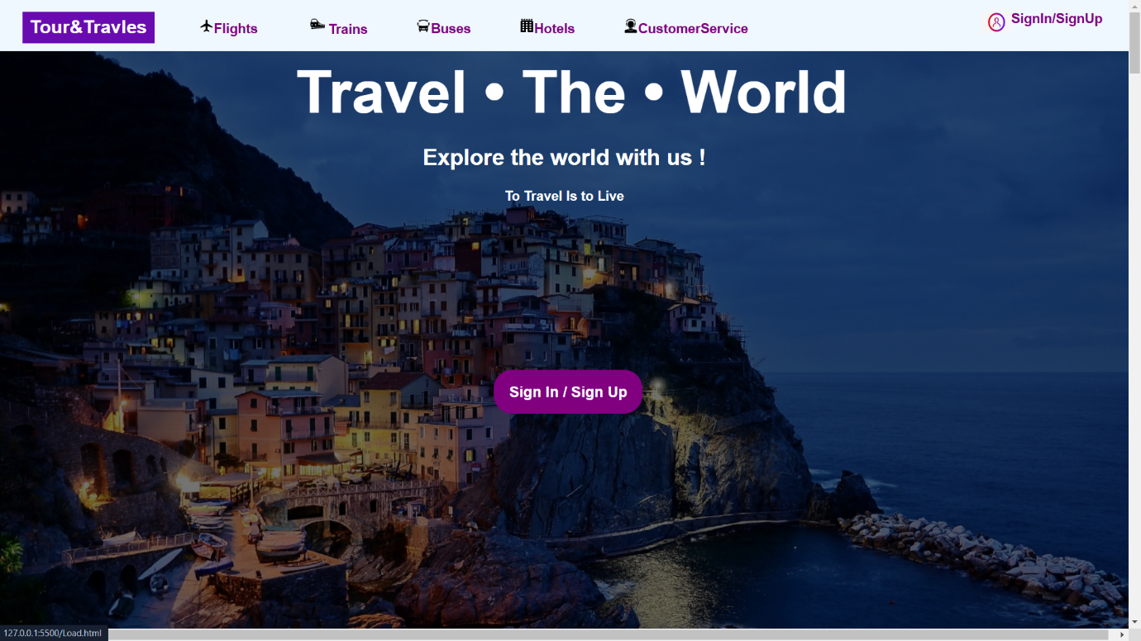

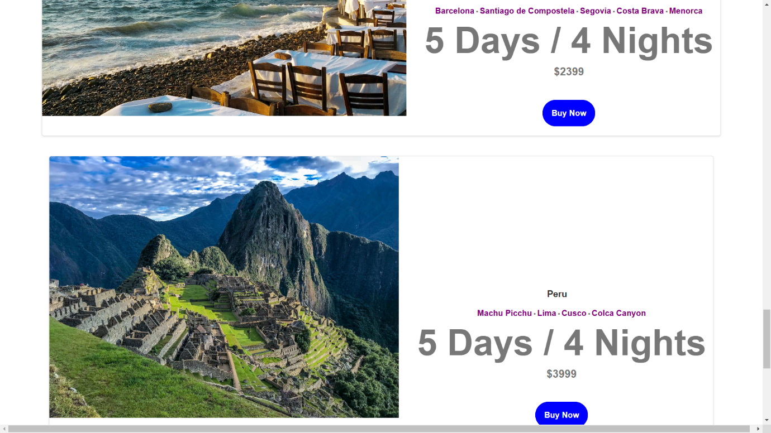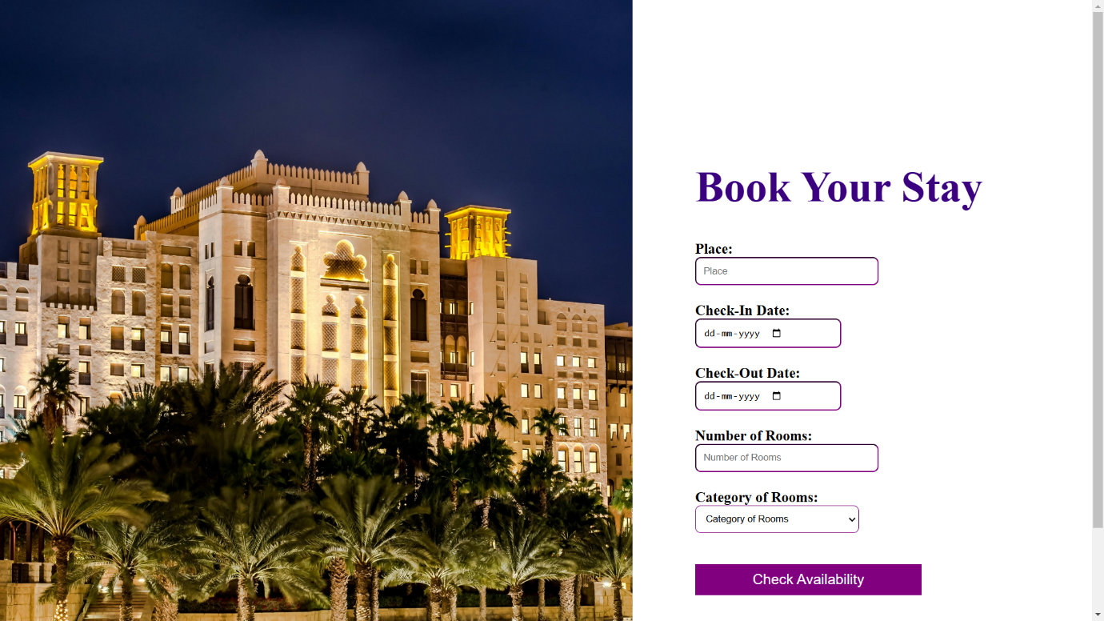

**References** :

1. Youtube.

2. ChatGPT

3.HTML 5 BLACK BOOK by Editorial Services , Dreamtech Press.

4.Code Sand Box.

**GITHUB** **REPOSITARY** **LINK** :

<https://github.com/DavKaran/Explore-Era>